

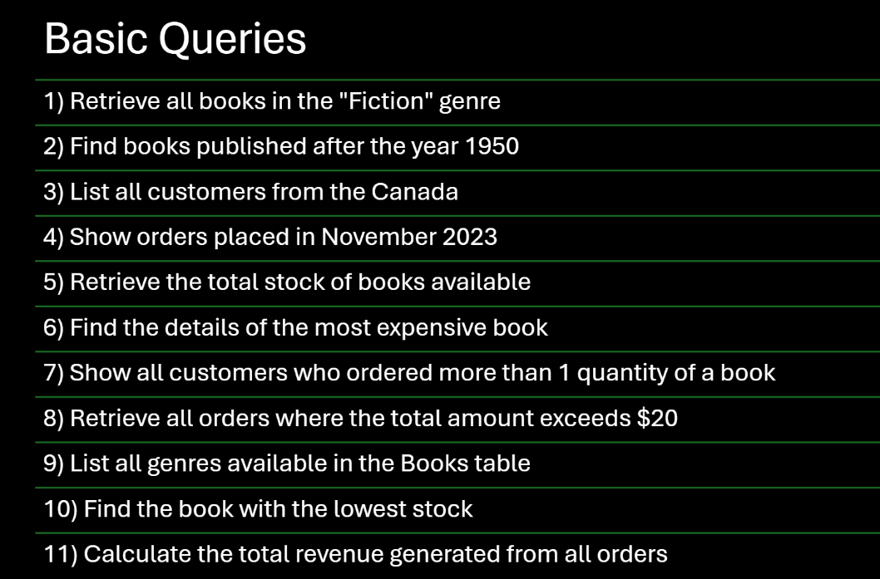

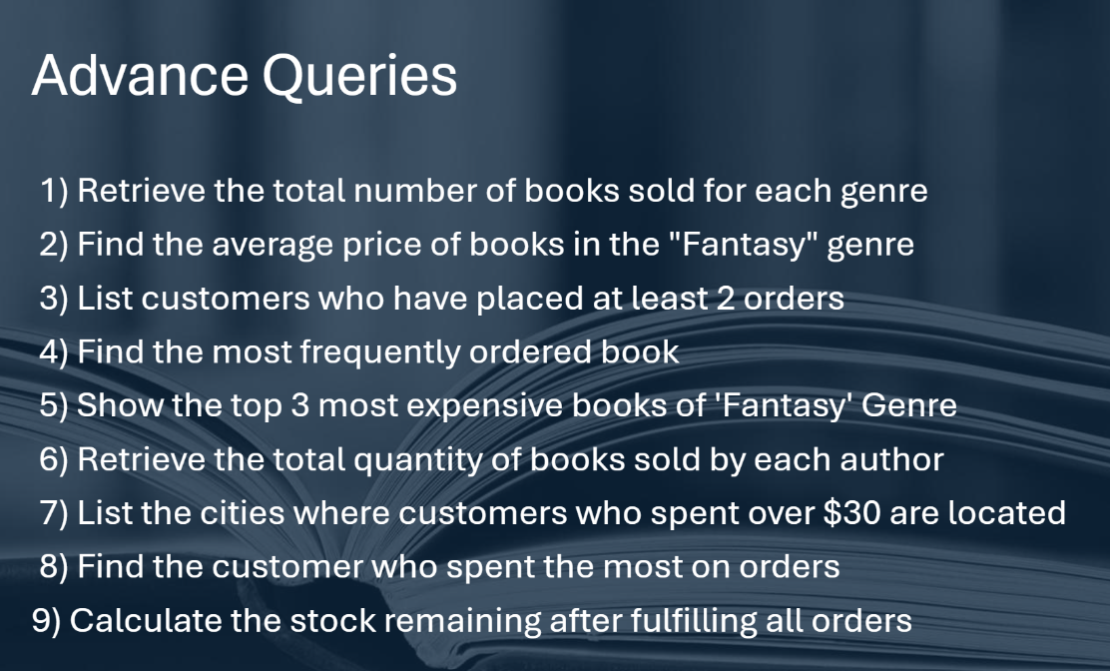

-- 1) Retrieve all books in the "Fiction" genre:

SELECT * FROM Books
WHERE Genre='Fiction';

-- 2) Find books published after the year 1950:
SELECT * FROM Books
WHERE Published_year>1950;

-- 3) List all customers from the Canada:
SELECT * FROM Customers
WHERE country='Canada';

-- 4) Show orders placed in November 2023:

SELECT * FROM Orders
WHERE order_date BETWEEN '2023-11-01' AND '2023-11-30';

-- 5) Retrieve the total stock of books available:

SELECT SUM(stock) AS Total_Stock
From Books;

-- 6) Find the details of the most expensive book:
SELECT * FROM Books
ORDER BY Price DESC
LIMIT 1;

-- 7) Show all customers who ordered more than 1 quantity of a book:
SELECT * FROM Orders
WHERE quantity>1;

-- 8) Retrieve all orders where the total amount exceeds $20:
SELECT * FROM Orders
WHERE total_amount>20;

-- 9) List all genres available in the Books table:
SELECT DISTINCT genre FROM Books;

-- 10) Find the book with the lowest stock:
SELECT * FROM Books
ORDER BY stock
LIMIT 1;

-- 11) Calculate the total revenue generated from all orders:
SELECT SUM(total_amount) As Revenue
FROM Orders;

-- Advance Questions :

-- 1) Retrieve the total number of books sold for each genre:

SELECT * FROM ORDERS;

SELECT b.Genre, SUM(o.Quantity) AS Total_Books_sold
FROM Orders o
JOIN Books b ON o.book_id = b.book_id
GROUP BY b.Genre;

-- 2) Find the average price of books in the "Fantasy" genre:
SELECT AVG(price) AS Average_Price
FROM Books
WHERE Genre = 'Fantasy';

-- 3) List customers who have placed at least 2 orders:
SELECT o.customer_id, c.name, COUNT(o.Order_id) AS ORDER_COUNT
FROM orders o
JOIN customers c ON o.customer_id=c.customer_id
GROUP BY o.customer_id, c.name
HAVING COUNT(Order_id) >=2;

-- 4) Find the most frequently ordered book:
SELECT o.Book_id, b.title, COUNT(o.order_id) AS ORDER_COUNT
FROM orders o
JOIN books b ON o.book_id=b.book_id
GROUP BY o.book_id, b.title
ORDER BY ORDER_COUNT DESC LIMIT 1;

-- 5) Show the top 3 most expensive books of 'Fantasy' Genre :
SELECT * FROM books
WHERE genre ='Fantasy'
ORDER BY price DESC LIMIT 3;

-- 6) Retrieve the total quantity of books sold by each author:

SELECT b.author, SUM(o.quantity) AS Total_Books_Sold
FROM orders o
JOIN books b ON o.book_id=b.book_id
GROUP BY b.Author;

-- 7) List the cities where customers who spent over $30 are located:

SELECT DISTINCT c.city, total_amount
FROM orders o
JOIN customers c ON o.customer_id=c.customer_id
WHERE o.total_amount > 30;

-- 8) Find the customer who spent the most on orders:
SELECT c.customer_id, c.name, SUM(o.total_amount) AS Total_Spent
FROM orders o
JOIN customers c ON o.customer_id=c.customer_id
GROUP BY c.customer_id, c.name
ORDER BY Total_spent Desc LIMIT 1;

--9) Calculate the stock remaining after fulfilling all orders:

SELECT b.book_id, b.title, b.stock, COALESCE(SUM(o.quantity),0) AS Order_quantity,
b.stock- COALESCE(SUM(o.quantity),0) AS Remaining_Quantity
FROM books b
LEFT JOIN orders o ON b.book_id=o.book_id
GROUP BY b.book_id ORDER BY b.book_id;

